49

Identifying Program-School Alignment Opportunities
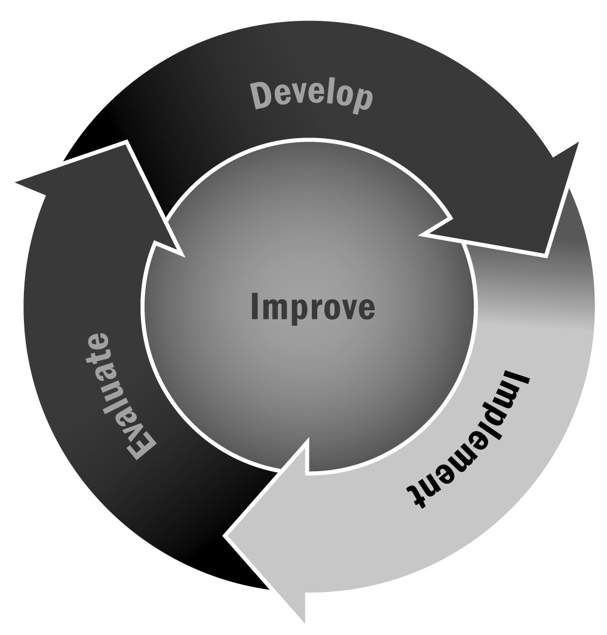
In Chapter 3, you learned that aligning with the school day is one way to promote learning and school success for youth who participate in your program. Asking school day teachers for specific suggestions on how your program can support students is a great way to begin alignment with the school day.
Directions: Use the following survey to ask school day teachers about the academic, social, emotional, and physical areas they are working on during the school day and in which their students need additional support or where they see opportunities for curriculum alignment with the afterschool and expanded learning program. For each subject or topic area, have them list specific skills they see as priorities. Then ask them to assign a priority level—low, medium, or high—to these skills. Once you have collected feedback from all teachers, use the matrix on the next page to keep the information organized.
Teacher Name:
Grade Level(s):

Subject/Topic Area | Specific Skills | Priority Level
 |  | ❒ | High
 |  | ❒ | Medium
 |  | ❒ | Low
 |  | ❒ | High
 |  | ❒ | Medium
 |  | ❒ | Low
 |  | ❒ | High
 |  | ❒ | Medium
 |  | ❒ | Low
 |  | ❒ | High
 |  | ❒ | Medium
 |  | ❒ | Low

Please identify areas where you think the program and school can collaborate to better support youth and reinforce important skills:
Directions: After collecting the forms from teachers, compile the information in a table like the example below. To aid in the decision-making process, you can sort the information by grade level, subject/topic area, or priority level. Use the blank form on the following page for your program.

Lincoln School Teacher Programming Needs – Example
Teacher Name and Grade Level | Subject/Topic Area | Specific Skills | Priority Level | Suggestions for Collaboration
Ms. Meier,  Grade 4 | Math concepts | - Long division  - Fractions | Medium | Math teachers can provide list of concepts to the program staff weekly
Mr. Davidson,  Grade 4 | Interacting with special-needs students | - Understanding disabilities  - Communicating respectfully | High | Form partnership with community organization for special-needs students
Mrs. Smythe,  Grade 5 | Life-science labs and experiments | - Life stages of insects  - Plant structures and functions | Low | Collect insects during program as part of Audubon Society enrichment program
Mr. Johnson,  Grade 8 | Time management | - Weekly homework planning  - Finishing long-term projects on time | Medium | Specific time in afterschool and expanded learning program to work on long-term English project
Mrs. Fleming, physical education,  Grades K–3 | Coordination | - Reinforce basic coordination skills like dribbling, balancing, running | High | Joint training for the afterschool and expanded learning staff and gym teachers

[School Name] Teacher Programming Needs – Template
Teacher Name and Grade Level | Subject/Topic Area | Specific Skills | Priority Level | Suggestions for Collaboration

